## Infovis Overview

1. In-depth overview of InfoVis

* Amplify cognition
* Visualization is really a cognitive process, whose purpose is insight, not pictures
* “Externalize” our thought on to the paper, display how our mind works to understand or solve problem
* Yield conclusions to questions not even originally asked. There can be surprises in the data.

1. **Purpose of InfoVis: Analysis and Presentation**

* Analysis
* Understand data better and act upon that understanding （cognitive process）
* Ultimately about solving problems, answering questions, performing tasks and accomplishing goals
* Useful when:

Questions are vague and you want to explore the data (exploratory data analysis)

The question is open to let yourself discover, but also explain and answer specific questions —— forces us to see what we are not expecting

* Not always useful when:

You need an explicit or exact answer to a question

No well-defined stopping rule (you don’t know whether you are done for answering a specific question)

* Analytic tasks for InfoVis
* Search: find a specific piece of information
* Browse: look over or inspect something in a more casual manner, seek interesting information
* **Searching & Browsing are high-level tasks in general**
* Monitoring: what has changed? What changes matter?
* Awareness: of something happening, the impact of something happening
* Presentation
* Communicate and inform others more effectively
* Visuals can serve as evidence or support (can frequently take the place of many words, while sometimes words are needed)
* Visuals can summarize, aggregate, unite, explain ...
* Human eyes are prone to be drawn to trends, patterns. But be careful that visuals might misrepresent the data.
* Visual analytics
* Combines automated analysis techniques with interactive visualizations for an effective understanding, reasoning and decision making.
* Main components: interactive visualization, analytical reasoning, computational analysis

1. Components of InfoVis

* Representation: clearly and accurately represent information
* Interaction: our ability to interact with it to figure out what the information means

## Multivariate Data, Data & Chart Basics

1. Basic data types

* **Nominal** (categorical)
* **Ordinal** (ordered set)
* **Quantitative** (can no math)

1. Data Marks

* Visual primitives in 2D or 3D space: Points, Lines, Areas, Volumes (从零维到三维)
* Placed in visual metaphors and mapped to values
* Graphical properties of data marks encode data values (can vary in effectiveness):

Size, Shape, Color, Orientation, Texture, Border, Thickness

1. Basic visual representation

* Binding data values to visual glyphs
* Emphasis salient features (for perceptual system)
* Augment cognitive process of people to reason about data

1. Terminology

* Data item: one data case
* Data attribute: also referred to as feature
* Data mark: visual encoding
* Aggregate function: a function that creates a numeric representation for a set of data cases (eg: average, count, sum)

1. Color design

* Contrast and analogy: contrast draws attention, analogy groups
* Ordering of color should be used when data has order
* Separation of color = separation of data
* Control value difference for legibility (易辨认性)
* Avoid visual clutter (variation in luminance can separate overlaid values into layers without causing visual clutter, while contrast in hues does not create this separation)
* Less is more (limit hue to a palette of two or three colors because there are limits to the number of items/colors people can distinguish between)

1. Data

* Univariate

Think of data items as one dimension and their values in another

* Bivariate

Think of two attributes as two dimensions, see the relationship (linear/curve/random pattern). Scatterplot is common

* Trivariate
* 3D scatterplot is possible, but isn’t great
* ^_^: still use 2D scatterplot, and use visual encoding to represent the third value (size, shape, color, thickness, saturation ......)
* Represent each variable in its own explicit way (treat each variable as univariate), but it is hard perceive relationships in this way.

1. Hypervariate data

* Parallel coordinates

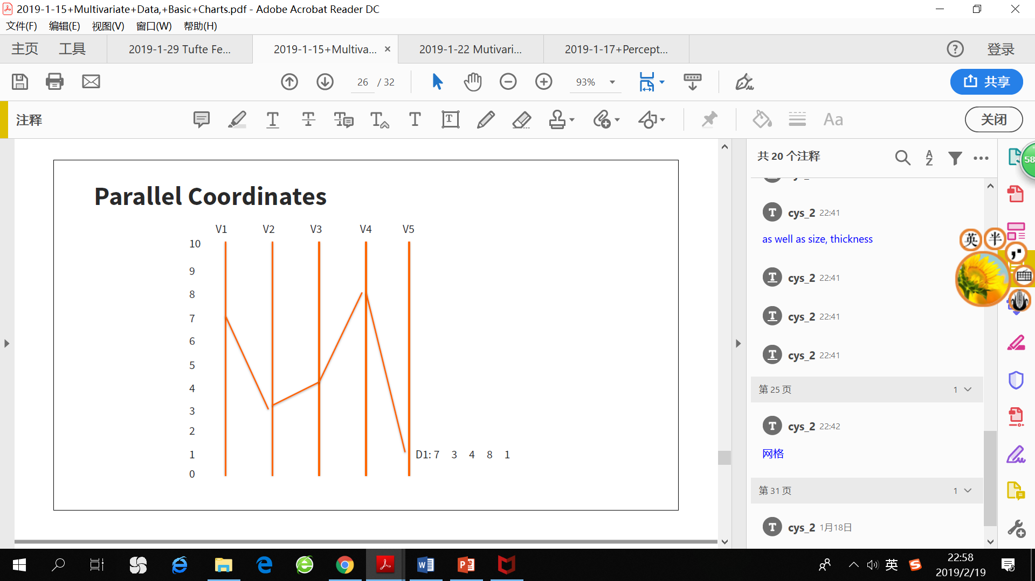

* Each data item has five attributes. 每一个柱子代表一个attribute，每个data item是一条折线
* Understand how well do parallel coordinates scale with attributes & data cases
* Dimensional reordering: it is very hard to visualize the relationship between non-adjacent coordinates, or you can change the order of coordinates to create new visual patterns.
* Scatterplot matrix
* All possible pairwise combinations
* Chernoff faces

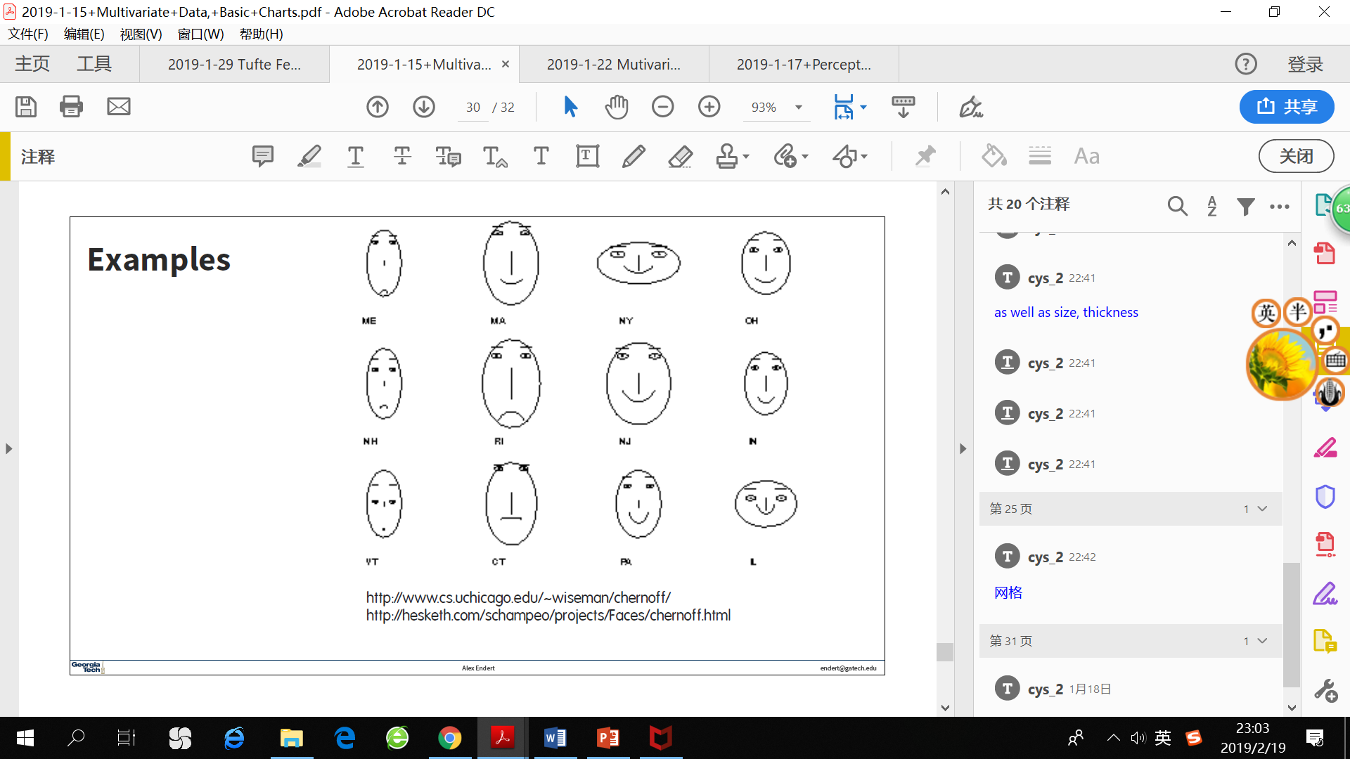

* Encode different variables’ values in characteristics of human face
* Star plots
* Space out n attributes at equal angles around a circle.
* Each “spoke” (辐条，轮辐) encodes an attribute’s value
* Each data item is represented by a “shape”

1. Questions to ask about any visualization

* How many attributes, what are their data types?
* How many data cases, what represent one data case in the vis
* How does it scale up (cases, attributes)?

## Perception & Gestalt

1. Perceptual processing

* Two stage process
* **Parallel** detection of color, texture, shape, spatial attributes

**Low-level**, occurs “automatically” without the need for focused attention, **rapid**

Often called “**pre-attentive**” processing

“**Mental Shortcut**”, good for target detection, boundary detection and counting

**Bottom-up**, **data driven**

* **Serial** processing of object identification

**Slow**, involves working and long-term memory

**Goal-directed**

**Top-down**

* Tasks that pre-attentive processing works well
* Target detection (if some objects exist? Especially with distinct feature)
* Boundary detection (can the elements grouped?)
* Counting

1. Gestalt Principles

* **Essence or shape of an entity’s complete form**
* Proximity —— we group together “proximate” objects.

Use this to show similarity, membership.

Items close together appear to have relationship, greater distance implies no relationship.

Use as an encoding for a data variable being visualized (eg: in a bar chart, bars close together has a same third value).

* Closure —— try to see collections of objects as creating a larger, more complete object

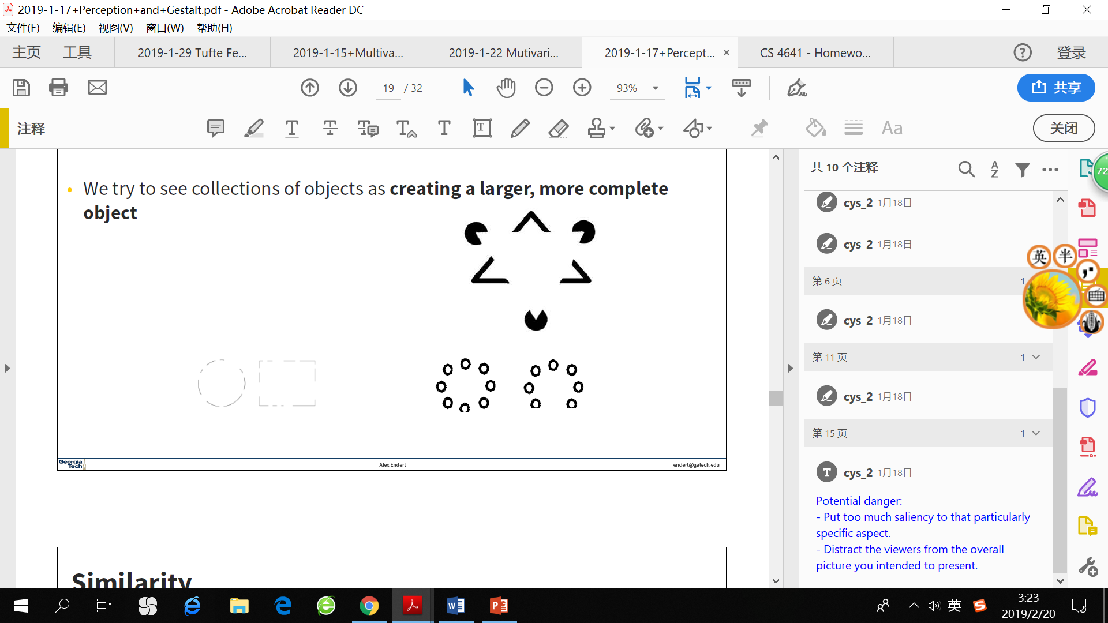

* Similarity —— group similar objects together
* Continuity —— we separate overlapping objects to give them a “smooth” interpretation

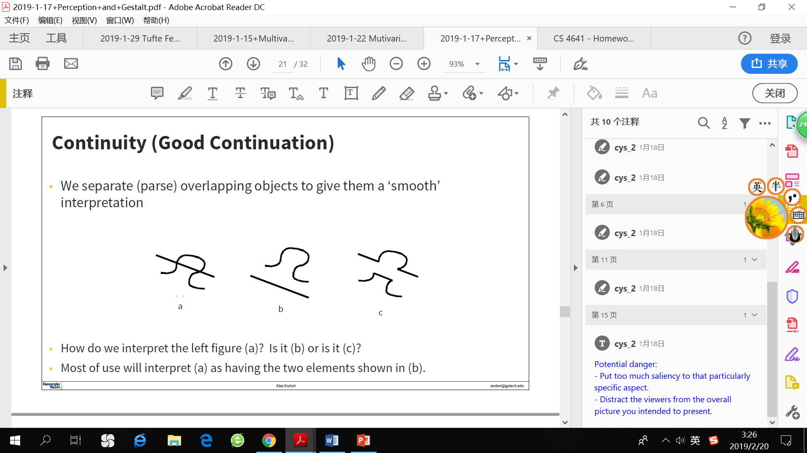

Most of us consider the shape in (a) as a combination of two shapes shown in (b) instead of (c).

* Continuity —— fill in the blanks



Note that filling in the blanks might be wrong.



* Common fate —— group together objects seem to moving in the same direction
* Figure/Ground —— you will discover different pattern when focusing on the object or background -> negative space defines an object or positive space defines it.
* Connectedness —— connected visual elements are seen as a whole

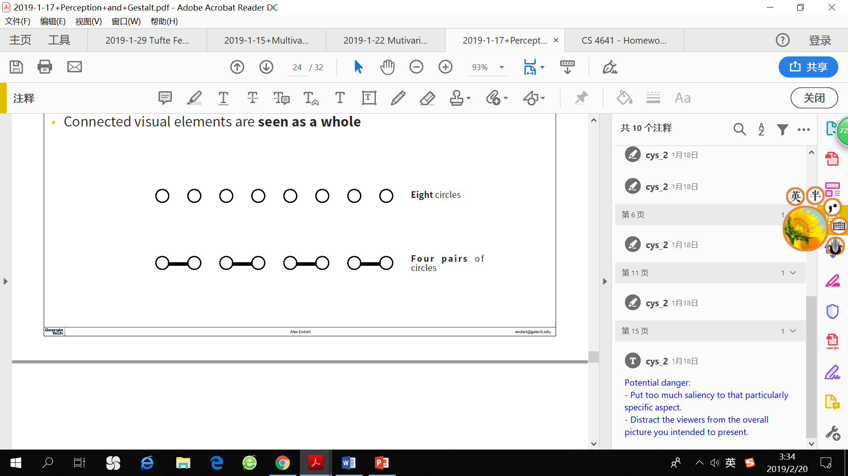

* Combination of principles reinforces each other. When one principle counters one another, one principle gonna to be stronger.

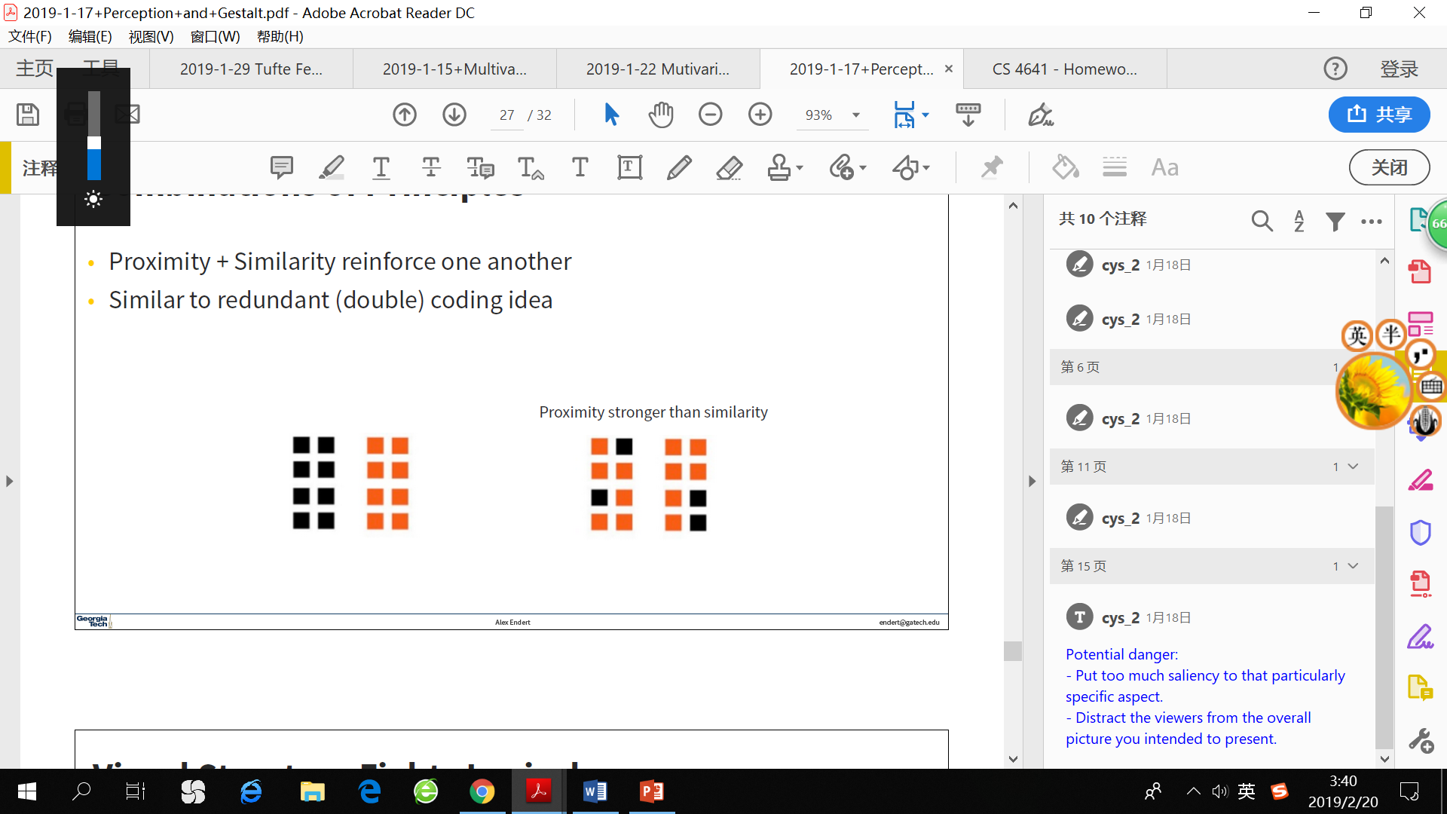

* Important!
* Use visual structure to reinforce the underlying logical structure or data
* Be careful not to combine principles which negate each other
* It’s ok to “double” encode to reinforce when you find it necessary

## Multivariate Visual Representation

1. Spreadsheet

* Each variable is positioned into a column
* Each data case is a row

1. TableLens



* Change quantitative values into bars

1. Multiple views

* Give each variable its own display

1. Scatterplot matrix
2. Chernoff Faces
3. Parallel coordinates

* Dimension reordering is allowed

1. Star plot
2. Mosaic plot

* Use more variables to sub-divide the whole area
* Very good for “proportion” tasks, but gives no insight on individual data

1. Parallel Sets —— apply parallel coordinates on categorical data

* Adopt parallel coordinates layout but uses frequency-based representation
* Distribution of values encoded as bars within each color category

1. Star Coordinates —— rather than represent a point as polyline, just accumulate values along a vector parallel to particular axis

* Each data case is a point
* Move your data point from center along each vector (distance = value)
* Data cases with similar values will lead to clusters of points
* Naïve approach to projection or multidimensional scaling

1. FLINA —— develop highly customized

* Combine multiple types of visualization (scatterplots, parallel coordinates, radar charts, etc) that are linked together and can be rearranged.
* Enable users to define and position coordinate axes freely and specify suitable visualizations by linking these axes

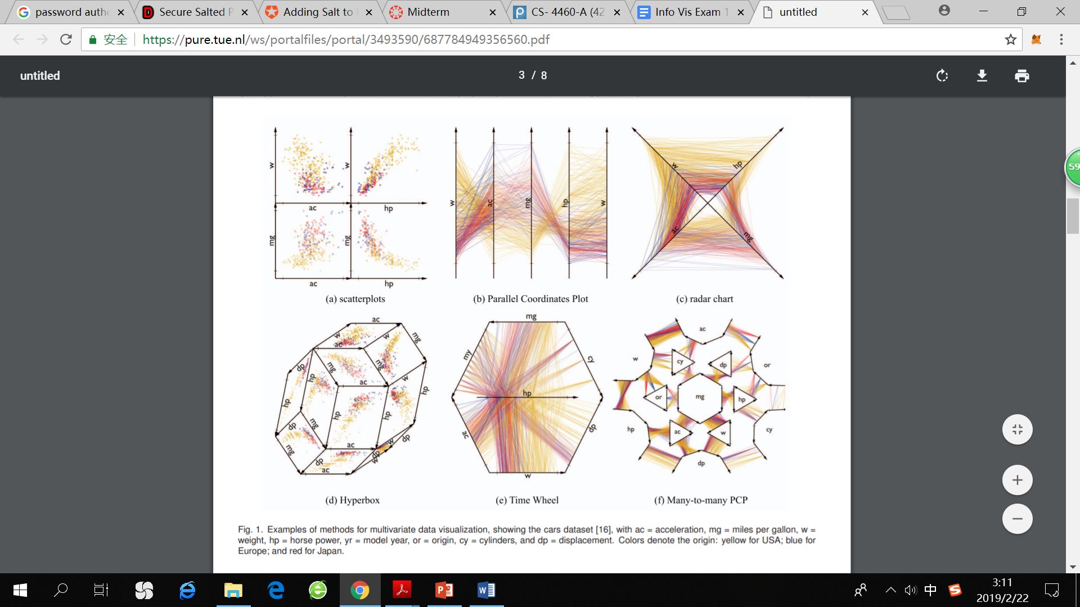

1. Dust & Magnet

* Data cases represented as an iron dust
* Attributes are magnets
* Data cases that are highly representative of certain attribute will be attracted to the corresponding magnet quickly.
* All magnets on display affect position of all dust
* Dust’s color and size an be encoded to represent attributes as well
* Individual power of magnets varies
* Interaction: moving a magnet makes all the dust move. There are different strategies for how to position magnets in order to explore the data.

1. Kenetica —— tablet visualization with physical-based metaphor for interactions
2. Pixel bar chart —— overload typical bar chart with more information about individual elements

* Make each pixel within a bar correspond to a data point in that group
* Color the pixel to represent the value of another attribute
* Each bar is ordered by color attribute too

## Design principles

1. Graphical excellence

* Well-designed presentation of interesting data
* Consists of complex ideas communicated with **clarity**, **precision** and **efficiency**
* Leverage human capability and complement what humans do well
* **Telling the truth** about the data

1. Chart integrity principles

* Is the dataset across the relevant **baseline**?
* Does the data use effective **scaling**?
* Does the data provide enough **context** for interpretation?
* Are the values of encodings proportional to values of attributes?

1. Measuring misrepresentation

* Visual attribute value should be directly proportional to data attribute value
* **Lie factor = (size of effect shown in graphic) / (size of effect in data)**

1. Design principle

* **Maximize data-ink ratio** (proportion of graph’s ink devoted to the non-redundant display of data-information)
* Above all else, show the data, then erase non-data ink, erase redundant data-ink, revise and edit.
* Avoid chartjunk
* remove extraneous visual elements that detract from message. (Eg: unnecessary gridlines, labels).
* Make grids, labeling very faint so that they recede into background.
* Sometimes chartjunk increases memorability of visualization, makes charts easier to be recalled.
* Utilize multifunctioning graphical elements
* Eg: stem-and-leaf displays both overall distribution and individual data points.



* Use small multiples (repeat visually similar graphical elements nearby rather than spreading far apart)
* Utilize narratives of space and time (tell a story of position and chronology through visual elements)



* Content is king (quality, relevance and integrity of the content is fundamental)

## Tasks & Analysis

1. Why need taxonomies?

* Need to understand what people might use them for
* Starting from two generic high-level tasks: searching & browsing
* Vis isn’t just about answering questions, but about asking better/new questions and knowing what to search for in the next step.
* Get the “gist” (精髓、要旨) of the data without knowing individual pieces of data

1. Task taxonomies

* **Structural decompositions of concepts to help us understand categories and their relationships**
* Low and high-level taxonomies exist

1. User tasks

* low-level, domain independent taxonomy of user tasks in visualization environments
* 11 basic actions: identify, locate, distinguish, categorize, cluster, distribution, rank, compare within relations, compare between relations, associate, correlate.

1. Mantra: “overview first, zoom and filter, then details on demand”
2. Task * data type taxonomy (to understand what people do with visualization) -> map specific data types with specific tasks.
3. Primary Task Taxonomy (Amar, Eagan & Stasko)

* Retrieve value: find attributes of some data cases
* Filter: find data cases satisfying certain conditions (and hide others)
* Compute derived value: compute an aggregate numeric function
* Find extreme: find data cases possessing an extreme value over its range
* Sort
* Determine range: find the span of values within the set
* Characterize distribution
* Find anomalies: identify any anomalies with respect to a given relationship or expectation
* Cluster: find clusters of data items with similar attribute values
* Correlate: determine useful relationships between two attributes

1. Tasks can be compounded
2. Tasks that are not included

* Basic math
* Uncertain criteria
* Higher-level tasks
* Qualitative comparation

## Time series, Geospatial & Storytelling

1. Timeseries

* Continuous (可理解为沿着时间轴一直存在，并不只是在特定时间点输出数据)
* Periodic (eg: temperature in Atlanta is periodic, with daily highs and lows, seasonal highs and lows)
* Non-periodic
* Discrete
* Have duration (eg: meeting, project phase...)
* No duration
* Periodic (eg: presidential elections, class meeting)
* Non-periodic
* Example —— Project management
* PERT/Gantt

Multiple steps, each having a time interval, some steps depend on other steps

* Example —— Time in 2D



* Example —— Time via parallel coordinates



* TimeSearcher —— create rectangles that function as matching regions
* TimeFinder —— search for matches based on angle + tolerance

1. Geospatial

* Data considerations
* **What? Attribute space**
* **When? Time space**
* **Where? Location space**
* Geometry
* Choropleth
* A map in which areas are shaded or patterned in proportion to the measurement of the statistical variable being displayed.
* Cartogram
* “value-by-area” map
* Depicts attributes of geographic objects as the object’s area. It changes the size of objects depending on a certain attribute.
* The geometry of regions is distorted in order to convey the information of an alternate variable. Eg: a world map in which the countries with a large population are drawn wider.
* Scalar Fields & Isolines
* Example —— Time + Geography
* Superimpose temporal events on a map
* Time via small multiples (many small maps along the time axis or matrix)

1. Storytelling

Tell a narrative to your audience using data, visualizations and story. Involves an author narrative in addition to visualizing data.